|  |  |  |
| --- | --- | --- |
|  | **Rochester Institute of Technology**  **Golisano College of Computing and Information Sciences**  **School of Interactive Games and Media**  **2145 Golisano Hall – (585) 475-7680** |  |

**Data Structures & Algorithms for Games & Simulation II**

**IGME 309**

**A03 - LERP**

For this assignment, there is starter code provided in the repository, you are not required to use said starting code or the framework for it, you can use your own solution, but it will be your responsibility to translate the provided startup code on your own.

In the class repository, I’ve included a solution under the _Binary folder. Please take a look at that and at the video instructions before continuing reading this document: <https://www.youtube.com/watch?v=BR85t6ZviPM>

The starter code will give you this out of the box:

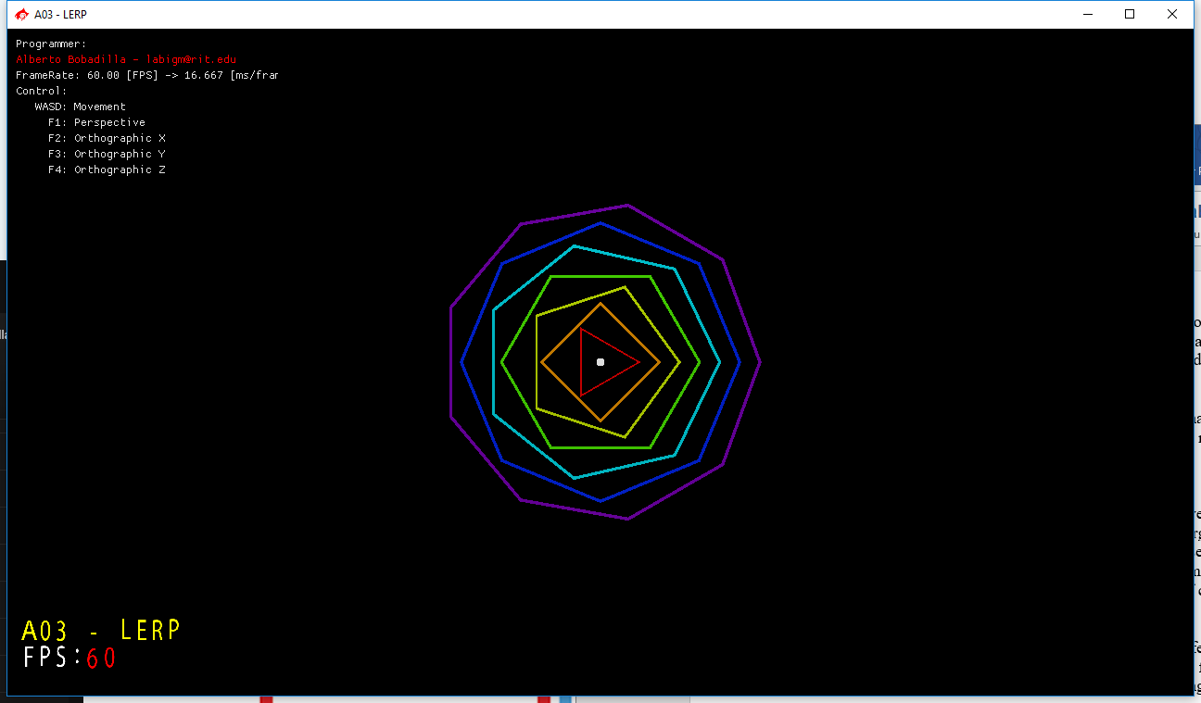

Once you execute it, the program will generate a companion .ini file that can be opened with any text editor, inside there is an orbits flag that you can modify to generate any number of orbits. The same goes for the solution of this assignment.

Although you cannot appreciate them in this image there are as many white spheres as there are orbits, all of them on top of each other at the origin. As you saw in the video and program, your challenge is to make all the spheres linearly interpolate in their respective routes.

Your grade will be 100% if your solution behaves like the one provided and deductions will happen as follows:

-10% I cannot initialize the number of orbits from the .ini file

-20% If you hardcode the routes/stops to any specific number. If you are having a hard time trying to make the system dynamic make at the very least 7 routes (I will not accept less than those). (this -20% does not include the -10% from the previous point, -30% in total if you hardcoded or set a maximum number of orbits)

-20% If you did not comment your code.

-70% if your spheres do not follow the orbits (i.e. They only move circularly around the origin instead of doing interpolation between the corners of the torus)

-100% your spheres are static at any given position.

+???% There is no specified extra credit for this assignment, but I’m willing to give you extra credit if you surprise me (in a good way)

Hints:

* Try doing the first 3 and you will notice a pattern that you can add into a loop.
* By not having a specific number of routes at compile time you are forced to use a data structure that can *dynamically* allocate values for you.
* I will try your solution with many different number of orbits.

***Submit to the dropbox labeled: A03 – LERP***

As usual the required submission asks only for the project folder, not the whole solution, it should be no larger than 200kb if you are using the starter code (and you remove this document from that folder). If you are using your own framework/engine please submit the whole solution. Push your solution to your repository with the comment “**A03 Deliverable**” then zip the project (or solution) and upload it to the dropbox, in the comments section you need to specify the address of your repository.

Example:

